Sample of PhysicalVerification Pictures.

The table below illustrates some physical status of the verified assets with photographic evidence.
Table XXX: Physical verification photos
ADMINISTRATION BLOCK WITH TWO UNITS | 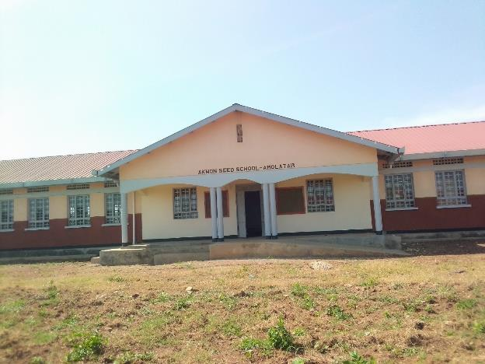
TYPICAL SET OF STAFF QUARTER’S BLOCK  (HOUSE BLOCK WITH TWO UNITS, KITCHEN AND TWO STANCE TOILET BLOCK) | 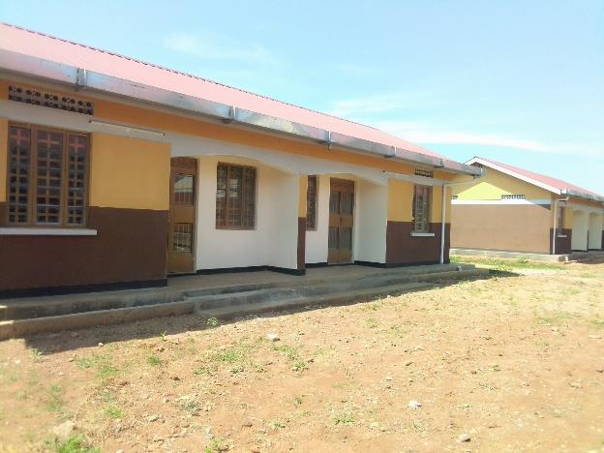
TYPICAL SET OF STAFF QUARTER’S BLOCK  (HOUSE BLOCK WITH TWO UNITS, KITCHEN AND TWO STANCE TOILET BLOCK) | 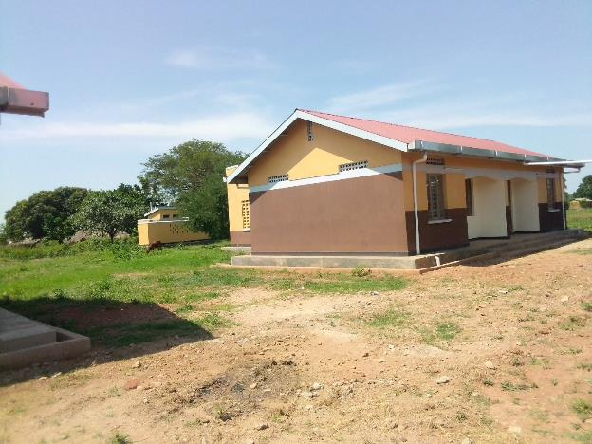
5,000LTRS HDPE CREST TANK WHICH FEEDS A 3,00OLTRS ELEVATED HDPE TANK WITH A PUMP | 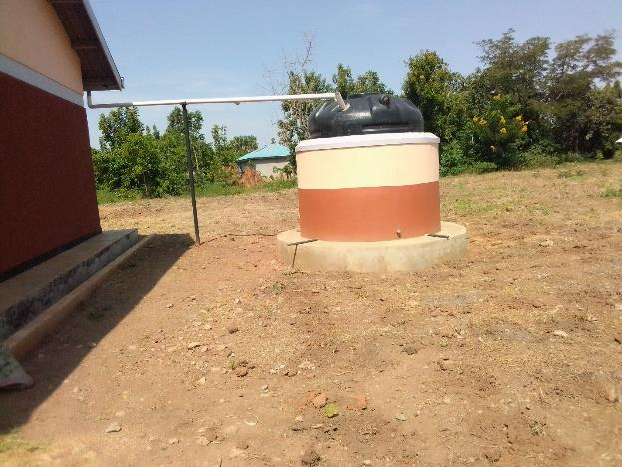
FRONT VIEW OF THREE CLASSROOM BLOCKS EACH WITH TWO UNITS | 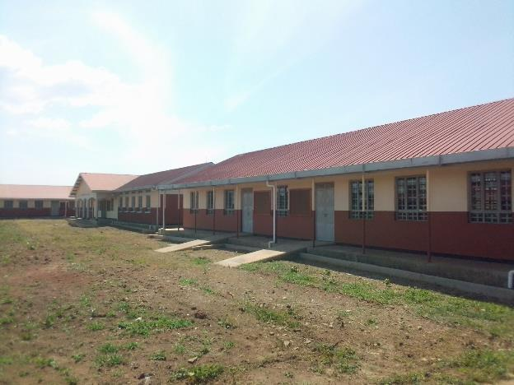
TOILETS | 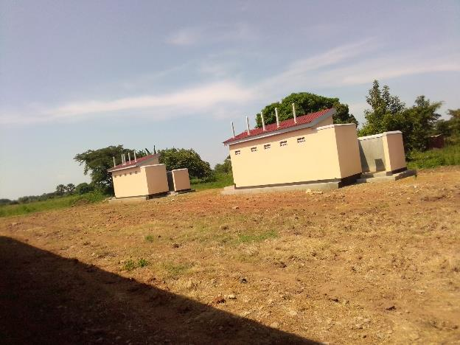
PLAY GROUND | 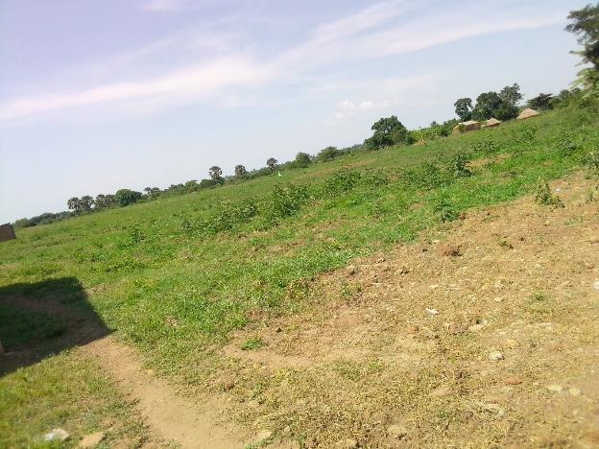
WALL LABORATORY TABLE WITH SHUTTERS, AND SINKS AND WATER CONNECTION | 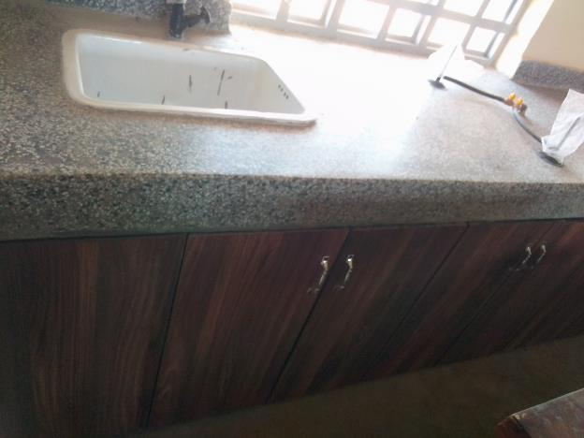
SAMPLE OF LAORATORY STOOLS | 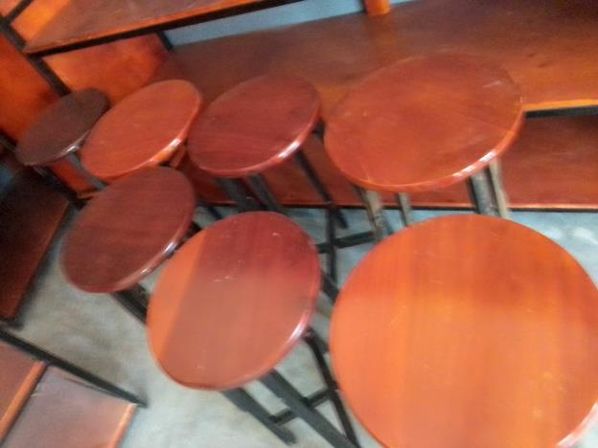
DESKS | 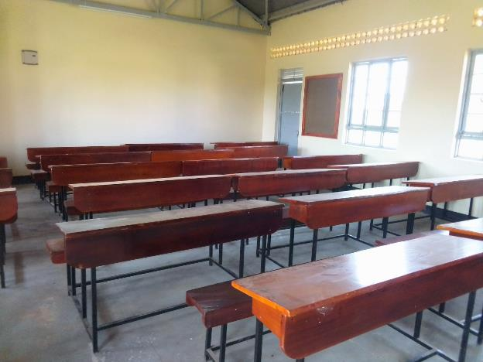
CHAIRS | 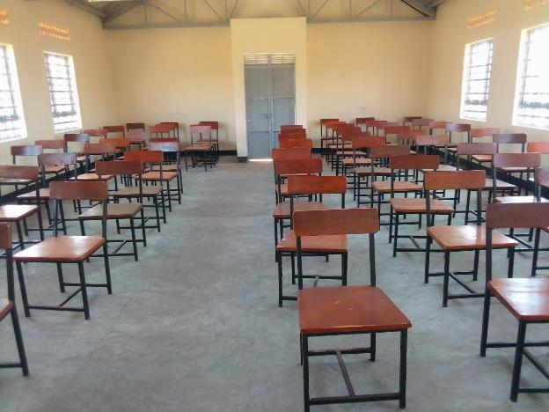
LIBRARY BOOK SHELVES, | 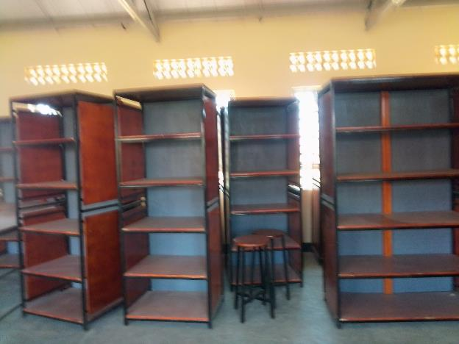
PIN BOARDS | 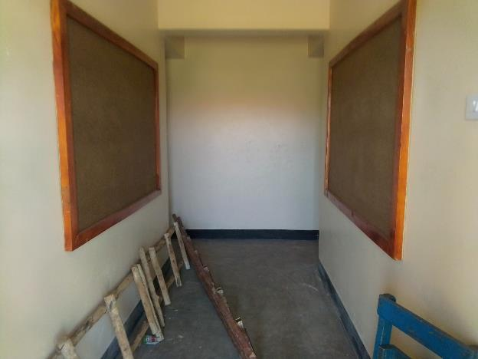
MULTI PURPOSE HALL | 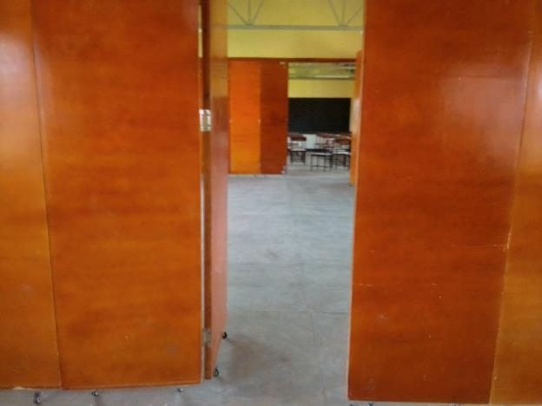
OFFICE TABLE | 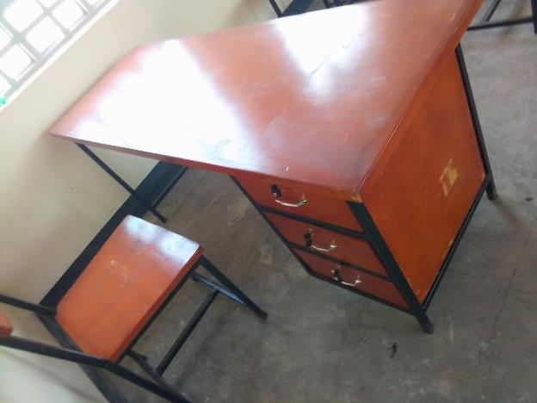
TABLES AND STOOLS IN LABORATORTY | 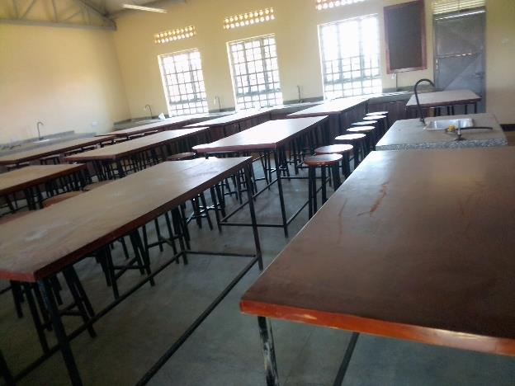
PLAY GROUND | 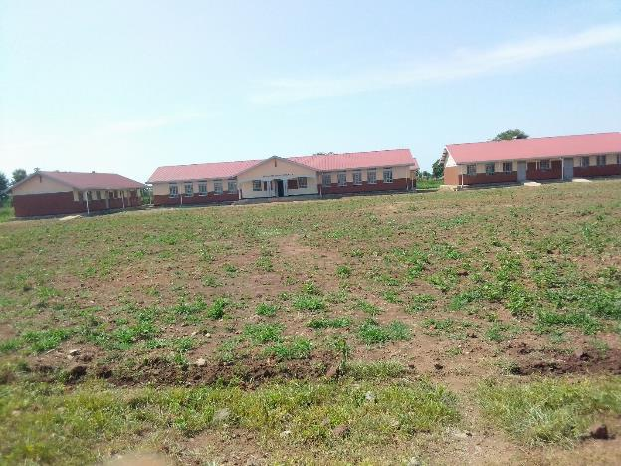
FOUR BLOCKS 2 UNIT WITH LABORATORY AND ICT LABAORATORY  AOTHER WITH MULTI PURPOSE HALL AND TWO UNUT CLASSROOMS | 